PE Studies Revision Notes - Functional Anatomy:

Muscle Types:
- Cardiac-
      - Found only in heart
      - Involuntary
- Smooth-
      - Found in diaphragm and in walls of blood vessels and intestines
      - Involuntary
- Skeletal-
      - Muscle adjoining to skeletal bones by a tendon
      - Voluntary
      - Striated in appearance - alternating dark and light bands
      - Fusiform: fibres run parallel to each other and produces quick but less powerful force
      - Pennate: fibres run at oblique angles and produce great force but tire easily

Muscle Fibre Type:
- Slow Twitch/Type I
      - Red in colour
      - Contract slowly
      - Slow to fatigue
      - Suited to aerobic activity
      - Recruited during low intensity work
- Intermediate/Type IIa
      - White in colour
      - Can sustain activity, OR, contract with a burst and fatigue
      - Recruited during high intensity work
- Fast Twitch/Type IIb
      - White in colour
      - Tire quickly
      - Contract quickly and powerfully
      - Suited to anaerobic work
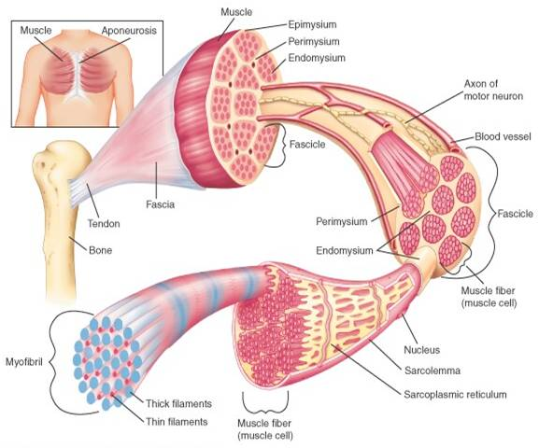
      - Recruited during very high intensity work

Muscle structure:
- Tendon - connective tissue adjoining muscles and bones
- Muscle belly - the bulk of the muscle
- Epimysium - thin connective tissue casing of muscle
- Fascicle- bundles of muscle fibres inside epimysium
- Perimysium - connective tissue surrounding Fascicle
- Endomysium - connective tissue surrounding each muscle fibre
- Muscle Fibre - made up of hundreds of myofibril
- Sarcolemma - thin casting of each muscle fibre
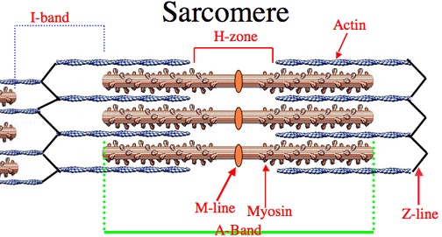
- Myofibril - comprise each muscle fibre
- Sarcomere - basic contractile unit of the muscle

Sarcomere:
- Myosin - thick myofilament
- Actin - thin myofilament
- Z-line - boundaries of adjoining sarcomeres
- H-Zone - space of only myosin, and can shorten or extend

Sliding Filament Theory:
- When an action potential reaches the end of the axon, it triggers the release of acetylcholine into the synaptic cleft
- This causes the muscle to be more positively charged, end plate potential
- Once threshold is reached, the muscle contracts and depolarises, causing release of calcium
- Neuromuscular stimulation causes calcium to be released into the sarcomere
- Calcium prompts reaction between Actin and Myosin Filaments by binding to actin
- This is given sufficient ATP is present
- Actin is pulled along the myosin via cross bridges; Powerstroke
- When totally contracted actin filaments overlap, H-Zone disappears
- When stimulation ceases cross-bridges release, acetylcholine is removed and muscle slides back to resting length
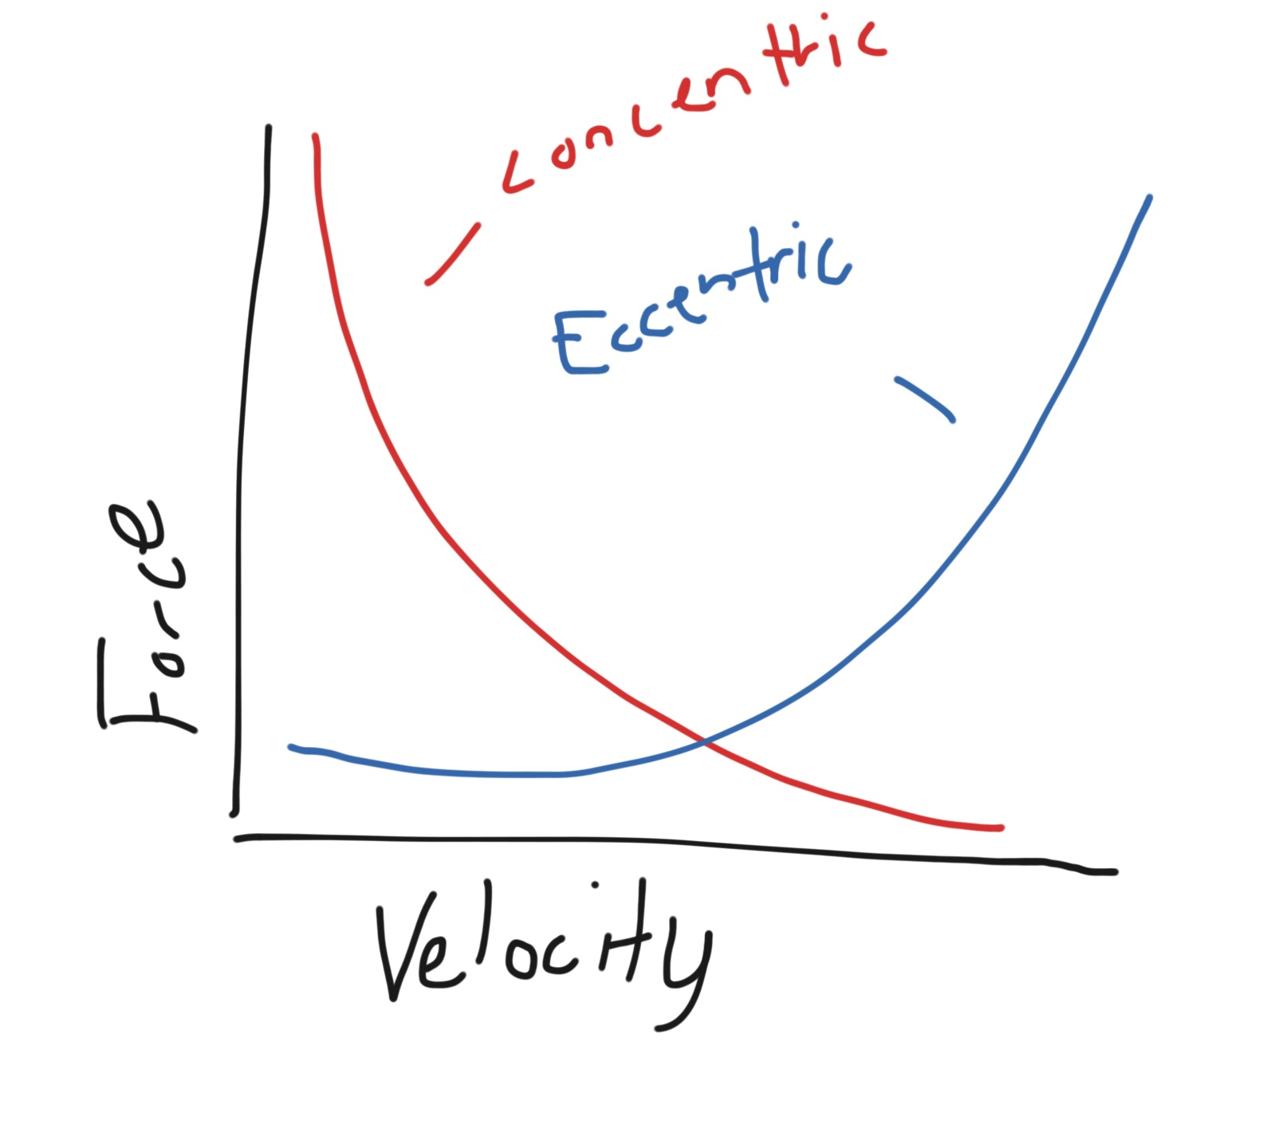
Force-Velocity:
- Isotonic force- change in muscle length against a constant load
      - Concentric results in shortening if muscle
      - Muscle can create increased force with a decreased velocity of concentric contraction
      - Maximum force comes at minimum velocity
      - Velocity increases at expense of force, vica versa

      - Eccentric results in extension of muscle
      - Muscle can resist increased force with increased velocity of eccentric contraction
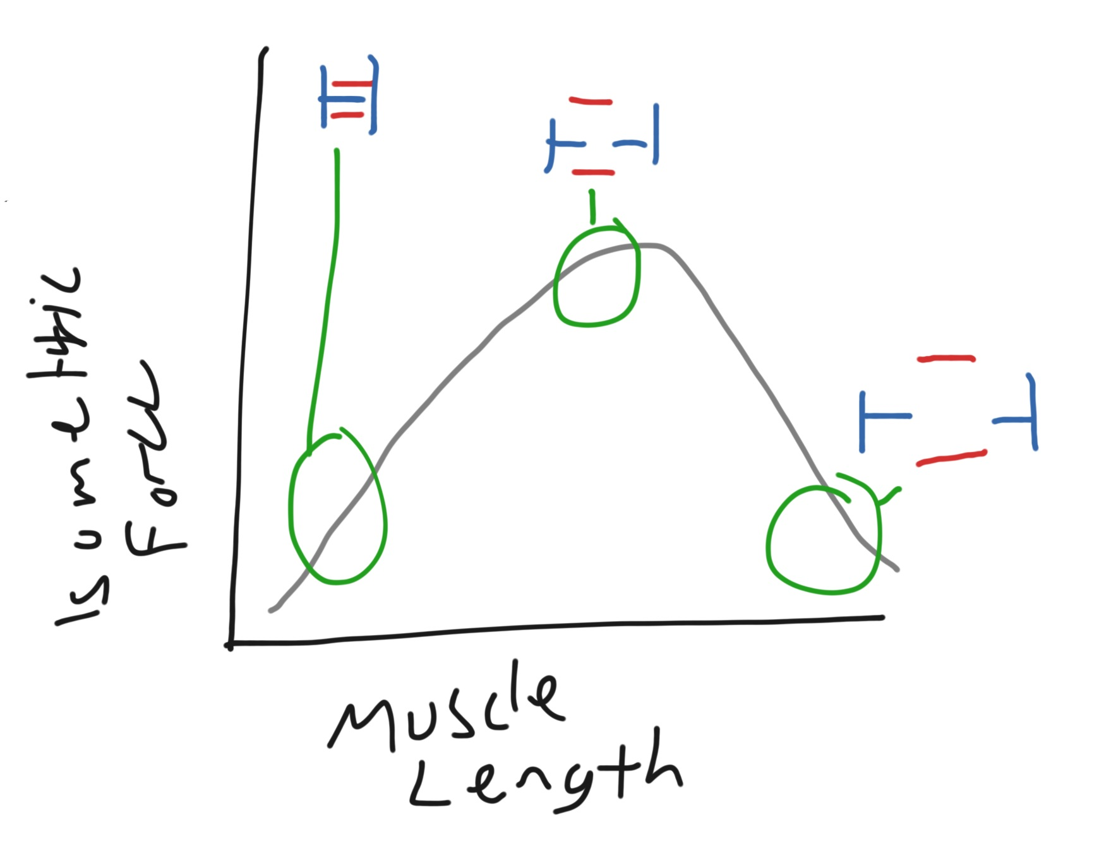
      - Increase in velocity will result in an increased force
- Isometric force - muscle does not change length

Force-Length:
- Amount of force that can be produced by a muscle is dependent on its length which it is held at
- Too Short - actin and myosin are maximally overlapped so cross ridge action is limited
- Too Long- slippage of cross ridges so fewer are able to catch
- Optimal- when muscle is at 80-130% of resting length
- Longer muscles have potential to move joints through a greater range of motion
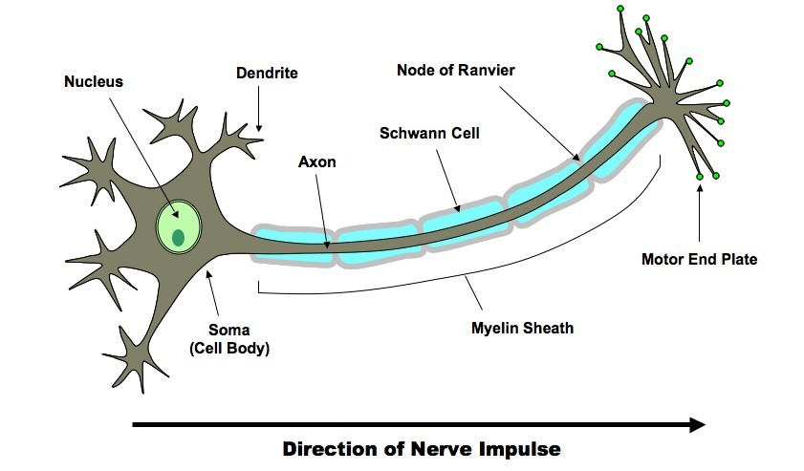
- Shorter muscles have potential to generate greater force
- Pre-stretching increases the potential of a muscle to produce force

Muscle Innervation:
- In order to contract, muscles must be stimulated by nerve impulses sent via motor neurons or nerves
- Message is sent from the brain, leaving as an action potential
- Motor Neuron-
        - Cell Body- directs the activities of the neurone. When it receives a signal it transmits information along the length of the axon
        - Dendrites receives signals from the central nervous system (or another neuron) and send them to the cell body
        - Axon- transmits a message to the muscle form the cell body
        - Motor End Plate- attaches to the muscle (neuromuscular junction)

- Motor Unit-
        - Refers to a single motor neuron and all its associated muscle fibres
        - Can comprise of 4 up to 1000 associated muscle fibres
        - Small units create Fine movement
        - Large units used for strength

- All or None Principal:
    - All muscle fibres within a motor unit will either contract with 100% force or none at all
    - The stimulus sent must be strong enough to breach threshold otherwise it won't fire
    - For a stronger contraction, the brain sends more stimuli, resulting in more motor units being called upon
    - All muscle fibres within the motor unit will contract at the same time (simultaneously)

Neuromuscular Response to Training:
- With strength training the first improvements are at a neuromuscular level
    - Improved technique
    - Recruitment if more motor units
    - Increased firing rate of motor unit
    - Firing pattern of motor units are better recruited

